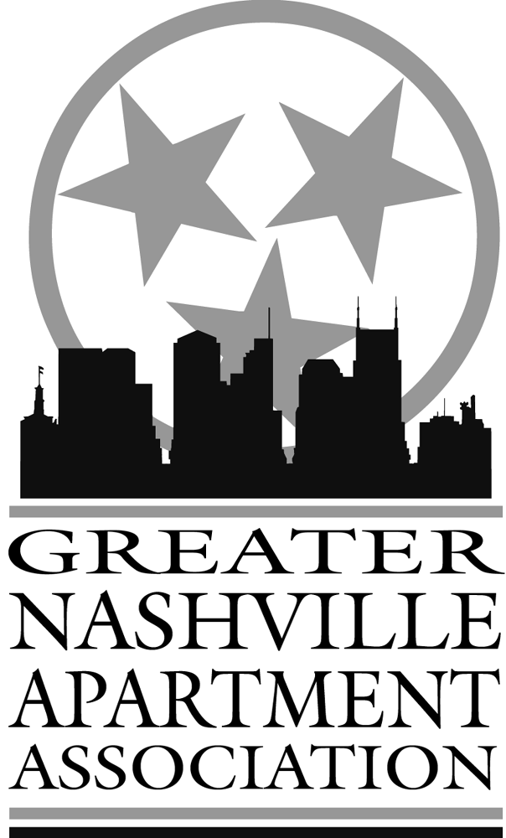
Join a Committee with GNAA
Find a committee that interests you. These committees depend on your participation and attendance to successfully meet their goals. It’s easy to do! Fill out the form below and return it to the GNAA office by fax at (615) 365-3571 or by email to info@nashvilleaptasn.org. GNAA: Grow With Us!

Apartment Tour is an annual tour of communities in a defined area designed to promote the benefits of apartment community living.
Awards Banquet is an annual celebration in which we honor our members for a variety of achievements throughout the year. This is our largest attended event and it continues to grow each year.
Beautification is the annual Apartment Community Beautification, Flowers, Model, Clubhouse, and Maintenance Shop judging. The awards are presented at our annual Awards & Installation Banquet.
Community Service offers a unique opportunity for our members to get involved in giving back to the community with sponsored events and contributions for displaced residents, underprivileged children, homeless residents in our city and breast cancer awareness.
Directory The GNAA Directory, including a Buyer’s Guide, is published exclusively for the use
of our members and is a tremendous resource for all of your multi-housing needs.
Education GNAA plays a key role in providing continuing education for multi-family professionals. Programs include both specialized courses and structured curriculum designed to result in industry designations of proficiency. Our educational programs are offered in a state-of-the-art training facility!
Golf Come play and network at the same time during our annual Golf Tournament. Other festivities during the tournament, such as Best Dressed Team, make this a one of a kind outing!
Membership is the key to the strength of our organization. GNAA offers a unique blend of membership services that can include opportunities for career enhancement, volunteer leadership and community involvement.
News & Events News & Events magazine is the number one resource to learn about the issues
and topics that affect GNAA members in their daily business. Our monthly publication is
produced in full color!
Programs The monthly General Membership meetings, Managers Luncheons, Maintenance
Luncheons and Associates Council Luncheons are the best way to stay educated on industry
trends and legal issues and also provide a great networking opportunity for our members.
Statistics GNAA publishes an annual Market Survey and quarterly reports with the most up to
Date market and trend information available. This publication is an incredible resource for
Industry professionals throughout the country.
Trade Show The GNAA Trade Show is held annually in July. Member companies gain
maximum exposure by showcasing their products and services in front of hundreds of multi-
family industry professionals with purchasing power.
Public Relations The objective of GNAA Public Relations is to promote Apartment living in a GNAA member community. To help our communities gain information in regard to their residents’ expectations, a recent Resident Survey was compiled at year end and is available to our members.

Name Property/Company_________________________
Phone Fax Email Address ____________________________
Committee(s) you would like to participate on ______________________________________
______________________________________________________________________

